JORDAN SCHOOL DISTRICT
Anthony Godfrey, Ed.D., Superintendent of Schools
West Jordan, Utah

Intradistrict Communication

DATE: May 12, 2026

TO: Principals
Assistant Principals

FROM: Michael Anderson, Associate Superintendent
Travis Hamblin, Director of Student Services
Matt Alvernaz, School Safety Coordinator

SUBJECT: Bleed Control (TECC) and First Aid Kits

New TECC kits (aka Bleed Control kits) for classrooms will be delivered to each school during the summer. Each school will also receive several First Aid Kits.

TECC Kits (Bleed Control):
- Kits currently in your building are being replaced with new and updated kits.
- Please collect the TECC kits from each classroom or instructional areas as a part of your end-of-year check-out process.
  - Large Bleed Kits or those mounted to a wall (usually in a Pelican storage case) do not need to be collected.
  - A typical TECC kit is pictured below.
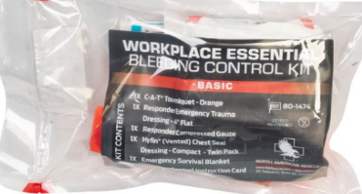

- TECC kits will be delivered by the District to the school at some point during the summer.
  - The old TECC kits that were collected at check-out will be picked up when the new ones are delivered.
  - Schools should retain at least 10 of the old TECC kits to place in other areas/rooms or for emergency use as the school sees fit.
  - A new TECC kit should be distributed to each classroom/instructional area and other larger gathering areas such as gymnasiums and auditoriums.
- Each School Safety Specialist (Administrator assigned school safety) should annually inventory the TECC kits in the school.

First Aid Kits:
- Will be delivered to the school during the summer at or about the same time as the TECC kits.
- One First Aid Kit should be placed in the main office and in each gymnasium.

If you have any questions or you would like to request to retain additional old TECC kits, please contact Matt Alvernaz (School Safety Coordinator) at matt.alvernaz@jordandistrict.org or 801-567-8623.

