Social Media Resources:
Martin Luther King Jr. and Grade Transmittal School Recess January 15-16, 2024
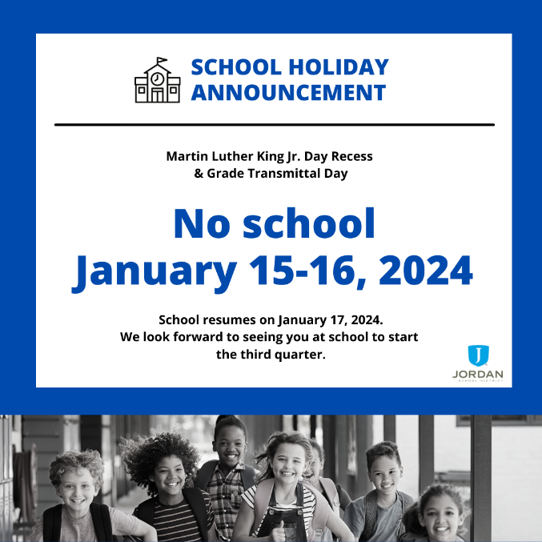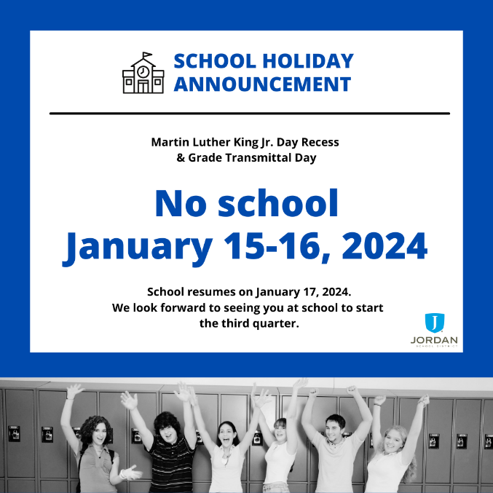

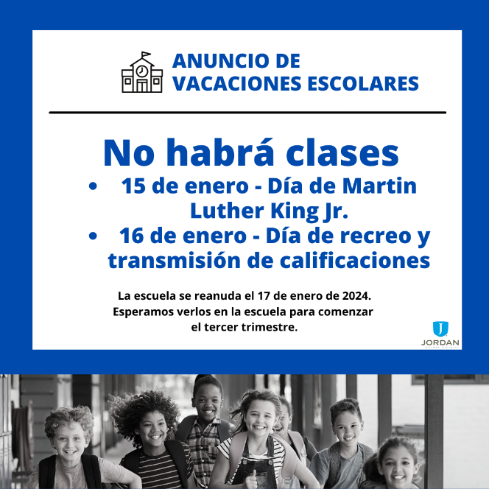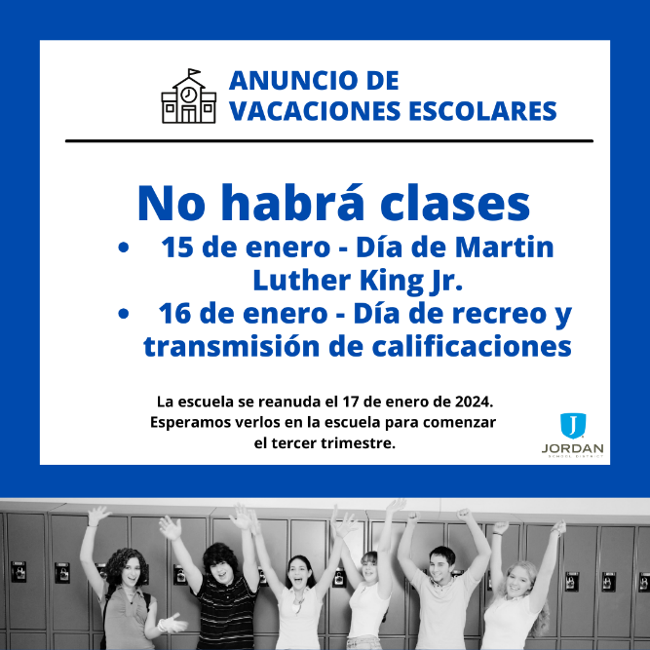
Secondary Flyers-
Facebook
English- https://acrobat.adobe.com/link/review?uri=urn:aaid:scds:US:28e74700-a0ca-3b0b-b9e1-87423fb2f547
Spanish- https://acrobat.adobe.com/link/review?uri=urn:aaid:scds:US:2a707079-8d49-31b3-b473-3b7e3e4199de
Instagram
English- https://acrobat.adobe.com/link/review?uri=urn:aaid:scds:US:c97a157b-ac24-3bfa-8456-1101ba9c0b03
Spanish- https://acrobat.adobe.com/link/review?uri=urn:aaid:scds:US:51da7041-6e8d-3a7f-9d8d-09edd43e44a0

Elementary Flyers:
Facebook
English- https://acrobat.adobe.com/link/review?uri=urn:aaid:scds:US:07269ac2-0575-36b3-b997-6521666e799f
Spanish- https://acrobat.adobe.com/link/review?uri=urn:aaid:scds:US:6c01fb62-84de-3bbd-b1fa-e97be8c68157
Instagram
English- https://acrobat.adobe.com/link/review?uri=urn:aaid:scds:US:c223b6c7-c1c5-35c3-817b-56889771ec10
Spanish- https://acrobat.adobe.com/link/review?uri=urn:aaid:scds:US:7307f2df-261e-3ed1-8bc2-7cef0d861121

