May Attendance JAM Memo Resources
Memorial Day Social Media Resources:
All Levels
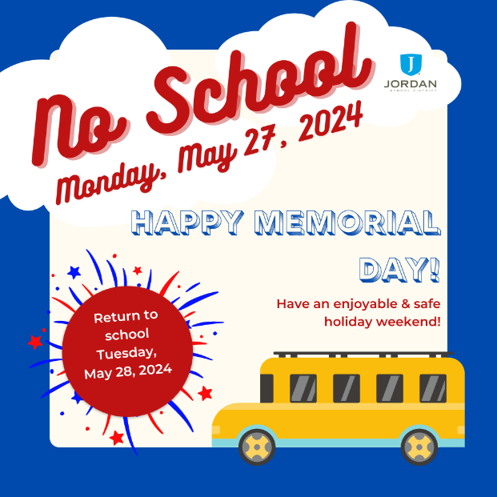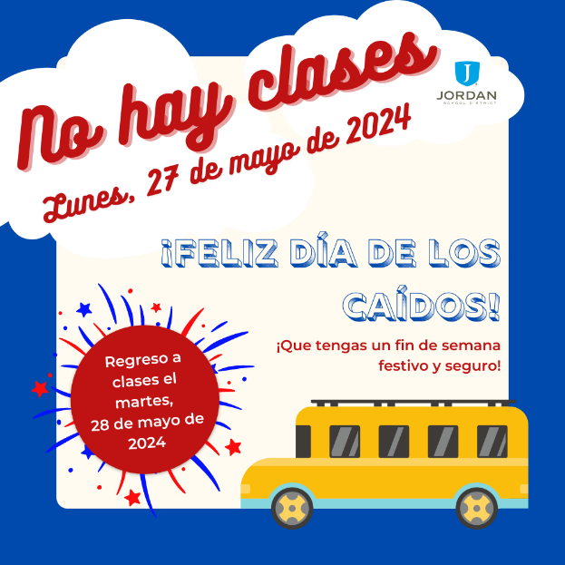
English:
PDF-https://acrobat.adobe.com/link/review?uri=urn:aaid:scds:US:834473a5-6daf-3442-b999-b09d8fa74dd4
Facebook png-https://acrobat.adobe.com/link/review?uri=urn:aaid:scds:US:93188777-3b49-394d-9698-ce9d9c0a35a1
Instagram png-https://acrobat.adobe.com/link/review?uri=urn:aaid:scds:US:f52826df-450d-3ee4-adfb-e28263266031
Spanish:
PDF-https://acrobat.adobe.com/link/review?uri=urn:aaid:scds:US:4574104a-1d1b-3981-8692-d2d40a415c5d
Facebook png-https://acrobat.adobe.com/link/review?uri=urn:aaid:scds:US:2f89501a-f9a4-32ae-92db-71bca10b2f22
Instagram png-https://acrobat.adobe.com/link/review?uri=urn:aaid:scds:US:939c1966-e3f6-3320-97f3-6ff6dd3c3784

End of the Year Attendance Best Practices Resources from Attendance Works:
https://awareness.attendanceworks.org/resources/what-to-do-when/

