JORDAN SCHOOL DISTRICT
Anthony Godfrey, Ed.D., Superintendent of Schools
West Jordan, Utah

Intradistrict Communication

DATE: Thursday, March 12, 2026

TO: High School Administrators

FROM: Carolyn Gough, Administrator of Teaching and Learning
Ben Jameson, Director of Evaluation, Research and Accountability

SUBJECT: Spring 2026 Testing Bulletin
________________________________________________________________________

School administrators may view the most up-to-date testing bulletin, complete with test administration and survey administration windows, by clicking on ‘High School’ under the heading Testing Bulletins on the front page of the website for Assessment, Research & Accountability:
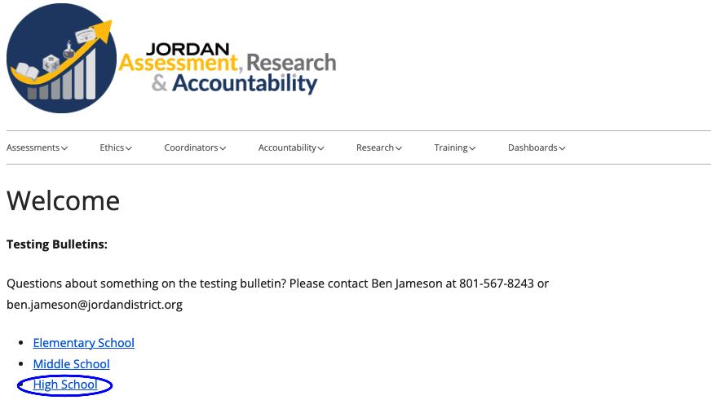
You may also access the high school testing bulletin here or attached with this memo.

For questions about any of the 24 federal, state or district assessments or surveys, please contact Ben Jameson in Assesment, Research & Accountability.

