JORDAN SCHOOL DISTRICT
Anthony Godfrey, Ed.D., Superintendent of Schools
West Jordan, Utah

Intradistrict Communication

Date: December 1, 2020

To: All Elementary, Middle, and Traditional High School Principals

From: Derek Anderson, Director of Accounting, Budgets, and Audits

Subject: December 2020 Budget Transfer Request

If you would like to transfer budget between your postage, supply, textbook, technology supply and equipment budgets, please complete the following, sign and return to Derek by January 4, 2021. If Derek does not receive this back from you by January 4, 2021, Derek will assume no transfer is requested. The next opportunity to make such a transfer is June 2021.

Please increase these budgets by the amounts indicated:
Postage 10-xxx-0050-2490-532 | $
Supply 10-xxx-0050-1090-610 | $
Textbook 10-xxx-0050-1090-641 | $
Tech. Supply 10-xxx-0050-1090-650 | $
Equipment 32-xxx-9932-4510-730 | $
TOTAL INCREASES | $

By decreasing these budgets by the amounts indicated:
Postage 10-xxx-0050-2490-532 | $
Supply 10-xxx-0050-1090-610 | $
Textbook 10-xxx-0050-1090-641 | $
Tech. Supply 10-xxx-0050-1090-650 | $
Equipment 32-xxx-9932-4510-730 | $
TOTAL DECREASES | $

Total increases must match total decreases!!

School Name: _________________________________________

School Number: _______________________________________

Principal’s Signature: ______________
As a reminder!

There is now a form on the District website on the accounting page. The web address is https://jordandistrict.org/departments/accounting/. At the bottom of the page there is a PDF titled “School Budget Allocation Transfer Form.”

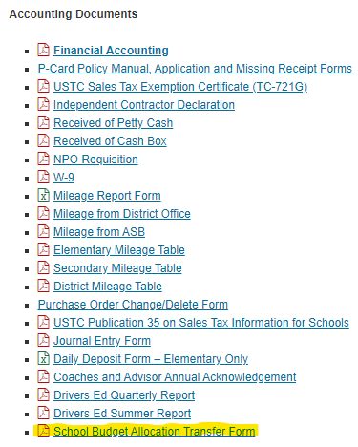
You can save a copy on your computer or use this link each time you need to submit a budget transfer.
Transfers will be posted at the end of each month. The reports sent to you on the 5th should reflect the transfers you have submitted.

The form looks just like the paper form you are familiar with. The totals will automatically calculate for you and increases should match decreases.

You do not have to wait for December transfers now, you can submit them from August through December. If you have any questions, please call or email Derek.
Extension – 88275;
E-Mail –derek.anderson2@jordandistrict.org

