Crucial Concerns Report

Skyward Web Finance System/Human Resources/Employee/JSD Employee Reports/Reports
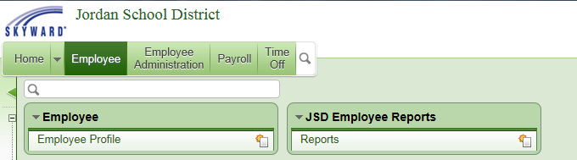

Select Crucial Policies Report - CP
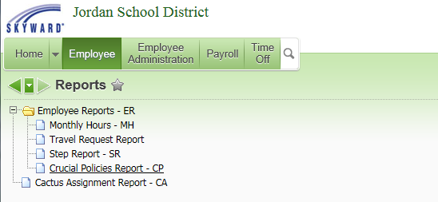

Add a Template
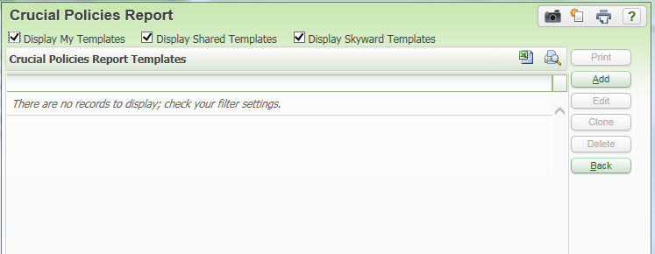

Enter a Template Description. Select whether to report on licensed or classified employees.
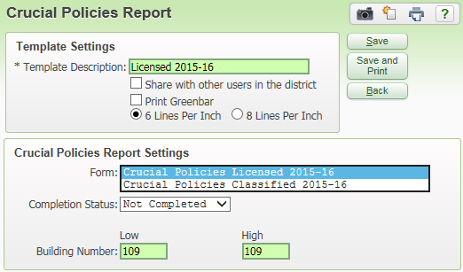

Select whether to report on all employees, or just those who have or have not completed their crucial concerns. Building number will be filled in for those with HR access to only one building, or enter the range of buildings to report on.
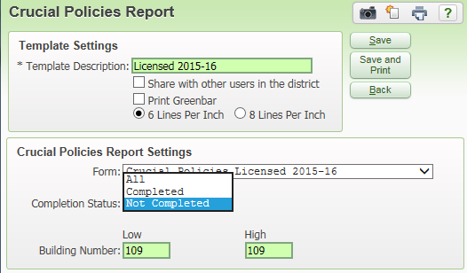

Example of report:
